EXERCISE 4
1. List the first and last names of all employees who draw less than or equal to 95000 and are programmers, Senior programmers or Multimedia programmers.
SELECT f_name, l_name FROM employee_data
WHERE salary <= 95000
AND (title = 'Programmer' OR title = 'Senior Programmer' OR title = 'Multimedia Programmer');
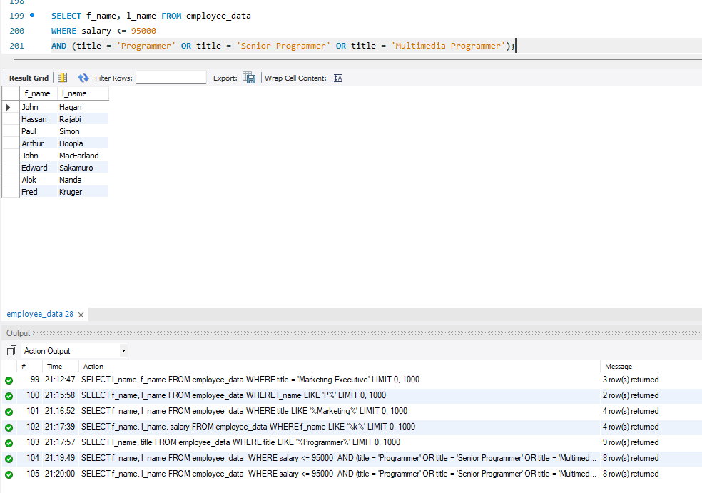

2. What is displayed by the following statement?
SELECT f_name, l_name FROM employee_data WHERE title NOT LIKE '%Marketing%' AND age < 30;
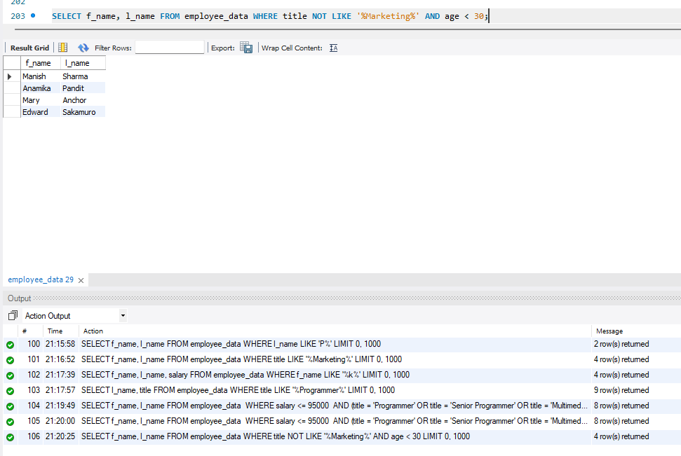
3. List all ids and names of all employees between 32 and 40 years of age.
SELECT emp_id, f_name, l_name FROM employee_data WHERE age BETWEEN 32 AND 40;
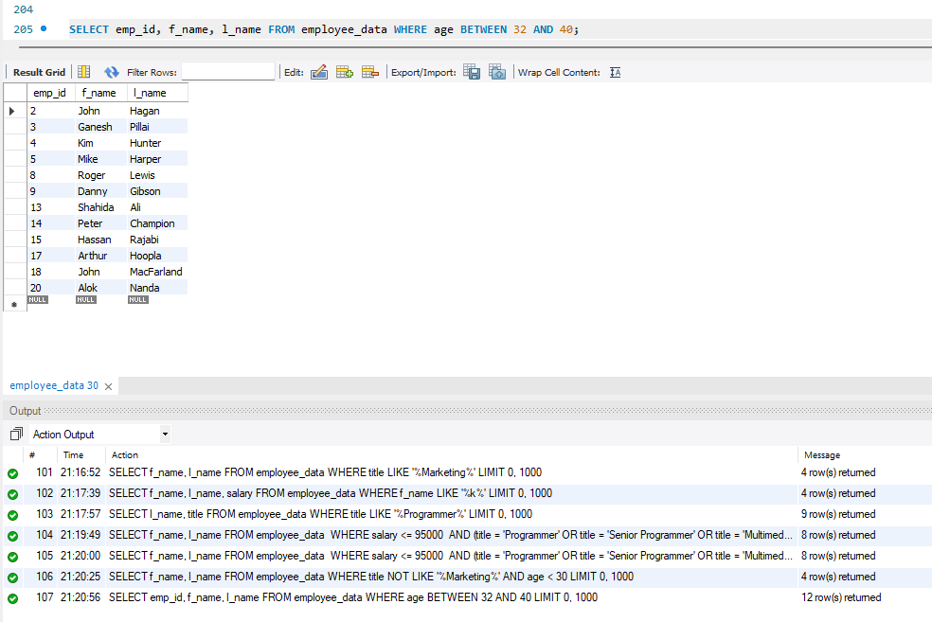

4. Select names of all employees who are 32 years of age and are not programmers.
SELECT f_name, l_name FROM employee_data
WHERE age = 32 AND title NOT LIKE '%Programmer%';
